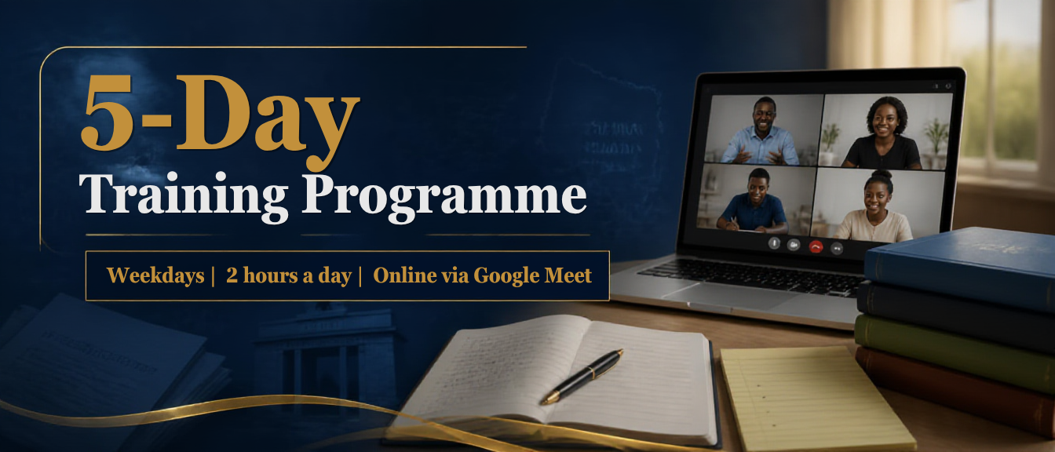
Gospel Chance 2026
5-Day Training Programme
Format | Weekdays Only • 2 hours per day • Online via Google Meet  Training Link:  https://meet.google.com/eei-afpn-xhk
Week and Time | 27th August 2026 to 31st August 2026  09:00–11:00 am (will be adjusted as needed)
Audience | Teenagers Awaiting BECE or WASSCE 2026 Results
Facilitation | Philomena Kafui Ama Ahey  philo.ahey@echance.org / +233(0)246370871
Theme Focus | Equipping and mobilizing teenagers awaiting BECE or WASSCE results to share the Gospel effectively with their peers.

Programme Overview
This 5-day online training programme is designed to orient participants to the history and purpose of Gospel Chance, build foundational gospel communication skills, and strengthen practical readiness for outreach and ministry engagement whilst building ethical leadership skills. Each session is structured into short, focused segments to fit a 2-hour weekday online format.
Delivery note — Keep cameras on where possible, use chat for quick responses, and breakout rooms will be for small-group activities. There is allocation of 2–3 minutes between segments for transitions and tech checks.
Learning Outcomes (By the End of Day 5)
Participants will be able to:
- Summarize the identity, history, leadership, and purpose of Gospel Chance.
- Explain key Gospel concepts clearly and biblically, using appropriate language for different audiences.
- Demonstrate practical methods for presenting the Gospel (including creative approaches) and responding to common questions.
- Plan and report on a simple outreach conversation flow and reflect on next steps for ongoing growth and participation.
Materials & Resources
Stable internet connection and device with microphone
Bible (physical or app) and notebook/pen
Google Meet access link (sent by organizers)
Any shared handouts/slides (sent after each day)
Participation Norms
Join on time; mute when not speaking.
Dress formally.
Use respectful language; keep discussions aligned to the topic and time.
Confidentiality: personal stories shared in training stay within the group.
Submit assignments and reports on time.

Day 1 (09:00–11:00) — Orientation & Foundations
 | Time | Session | What to do (Facilitator as Guide)
 | 09:00–09:10 | Devotion Time | Theme: Jesus Came - Day 1
 | 09:10–09:20 | Welcome & Orientation | Orientation Session
 | 09:20–09:40 | Organization Background | History of E-Chance International: Gospel Chance.  Its Vision, Mission and Objectives  Founders  Board Members
 | 09:40–09:50 | Recognition & Impact | Awards won by E-Chance International  About Gospel Chance  (Experience It! Express It!)
 | 09:50–10:05 | Introductions | Introduction of participants
 | 10:05–10:25 | Core Teaching | The Final Authority:  1. God's Message  2. Who is Lost?
 | 10:25–10:35 | Worship | Song Time
 | 10:35–10:50 | Main Topic | Topic: "Can the Hand and Fingers Preach the Gospel?" (My Body the Temple of God).  Who God Is  The Teenager’s Desire
 | 10:50–10:58 | Practice | Participants Activity Time  Define a simple Gospel outline (God →) and model a 2-minute explanation.
 | 10:58–11:00 | Close | Closing Remarks
Facilitator prompt (Day 1) — Keep the tone warm and academic. Use short transitions between segments and confirm understanding with quick questions in chat (e.g., “In one sentence, what is the message?”).

Day 2 (09:00–11:00) — Gospel Clarity & Communication Basics
Time | Session | Focus
09:00–09:10 | Devotion Time & Recap | Theme: Jesus Came - Day 2  Recap Day 1 highlights; Set goals for the day.
09:10–09:30 | Core Message Structure | Scripture Commands Us  Teenagers Under Attack?  Sin
09:30–09:50 | Audience Understanding | Song Time  The Teenager’s Faith  Discuss common listener backgrounds and how to explain terms clearly.
09:50–10:05 | Breakout Practice | Define a simple Gospel outline (God → Sin →) and model a 2-minute explanation.  In groups, practice a 2-minute Gospel explanation; Partner gives feedback using 2 strengths + 1 improvements.
10:05–10:30 | Q & A and Misconceptions | Address likely questions; Practice calm, respectful responses without arguments.
10:30–10:55 | Guided Role-Play | Facilitator-led role-play with volunteers; Group identifies what was clear and what to improve.
10:55–11:00 | Closure | Assign a short take-home: Write a 5–7 sentence gospel explanation in your own words.

Day 3 (09:00–11:00) — Practical Methods & Creative Gospel Sharing
Time | Session | Focus
09:00–09:10 | Devotion Time & Recap | Devotion Time  Theme: Jesus Came - Day 3  Quick recap; Review 2–3 participant take-home examples.
09:10–09:30 | Conversation Starters | Teenagers Can Receive Jesus  Grace  How to begin respectfully; Asking permission; Listening first; Using everyday topics to transition.
09:30–09:50 | Creative Illustration | Song Time  The Young Missionary’s Journey  Introduce simple object/gesture-based illustrations (including hands/fingers concept) to support understanding.
09:50–10:10 | Small-Group Design | Define a simple Gospel outline (God → Sin → Grace →) and model a 2-minute explanation.  Breakouts: Create a 2-minute presentation using a simple illustration + clear message + response question.
10:10–10:45 | Share-Outs | Groups present; Facilitator will provide structured feedback (clarity, accuracy, tone, timing).
10:45–11:00 | Reflection | Participants write 3 personal commitments for improvement before Day 4.  Participants to secure at least one prayer partner (To be introduced to parent/guardian before Day 4)

Day 4 (09:00–11:00) — Responding Well: Objections, Sensitivity, and Follow-Up
Time | Session | Focus
09:00–09:10 | Devotion Time & Recap | Theme: Jesus Came - Day 4  Review Day 3 learning and commitments; Set day’s expectations.
09:10–09:35 | Common Objections | Repentance  Teenagers Leading SDG 2030 and Africa Agenda 2063  Practice responding to questions with humility and clarity (e.g., suffering, hypocrisy, “all religions are same”).
09:35–09:55 | Listening Skills | Song Time  The Missionary’s Reward  Active listening, empathy statements, and asking good follow-up questions without pressure.
09:55–10:25 | Role-Play Circuits | Define a simple Gospel outline (God → Sin → Grace → Repentance →) and model a 2-minute explanation.  Triads: Speaker, Listener, Observer. Rotate every 2 minutes; Observer tracks tone, clarity, and respect.
10:25–10:50 | Follow-Up Pathways | How to invite next steps (prayer, reading, meeting,) and how to support continued engagement safely and ethically.
10:50–11:00 | Closure | Quick check-out: One insight and one question to carry into Day 5.  Participants to secure at least one more prayer partner (To be introduced to parent/guardian before Day 5)

Day 5 (09:00–11:00) — Integration, Practice Assessment, and Commissioning
Time | Session | Focus
09:00–09:10 | Devotion Time & Recap | Theme: Jesus Came - Day 5  Recap Days 1–4; Set a respectful, focused tone for final practice.
09:10–09:30 | Personal Readiness Check | Song Time  Faith  Participants review their gospel outline and identify one area to simplify or strengthen.  The Missionary’s Faith Proved
09:30–10:20 | Summative Practice | Define a simple Gospel outline (God → Sin → Grace → Repentance → Faith) and model a 2-minute explanation.  Breakout assessments: Each participant delivers a 3-minute gospel presentation + 2-minute response to a question; Facilitator/Peers score using a simple rubric (clarity, accuracy, tone, timing).
10:20–10:40 | Feedback & Growth Plan | Share strengths and next steps; Set personal practice targets for the next two days.
10:40–10:55 | Programme Close | Final reflection, encouragement, and commitments (what you will start/stop/continue).
10:55–11:00 | Closing | Explanation of application process, selection, appointment, outreach event and reporting and payment of allowance.  Closing prayer and next-meeting information.

Assessment Approach
Formative (Days 2–4): participation checks, short role-plays, chat responses, and facilitator observation.
Summative (Day 5): Timed presentation and Q & A practice using a simple rubric (clarity, accuracy, tone, structure, next-step invitation).
Post-Training Programme Actions
Sharing final resources/handouts and the recorded session link.
Participants go through application process (for selection).
Collection of feedback via a short Google Form.

